Expression of Interest – National Disability Research Agenda
August 2020
National Disability Research Partnership

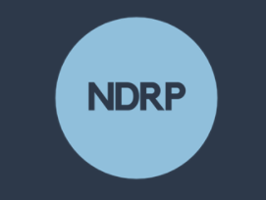
Introduction
This expression of interest form accompanies the Request for Proposal – National Disability Research Agenda. It is the first phase of a submission process. Please keep your response to a maximum of three (3) pages and submit the expression of interest to info@ndrp.org.au before 17:00 AEST 28 August 2020.

Partnership
Please list the organisations that will be part of the proposed partnership for this submission. Please note consortia must be led by a university or a research institute and include at least one advocacy organisation.

Capability
Please outline relevant experience in similar desktop reviews, facilitating inclusive consultations and research agenda setting.

Approach
Please provide a brief outline of the proposed approach to the project.

Accessibility and inclusion
Please outline the consortium’s experience in co-design, accessible communication and inclusive research.

